Name – Jasmine Dade

Student id – 100420168

Course – INFO 1113 (S10)

URL - <https://github.com/Jasminedade/project.git>

Purpose of the course - System analysts solve business problems through analysing the requirements of information systems and designing such systems by applying analysis and design techniques. This course deals with the concepts, skills, methodologies, techniques, tools, and perspectives essential for systems analysts.

Learning outcomes –

* A firm basis for understanding the life cycle of a systems development project.
* An understanding of the analysis and development techniques required as a team member of a medium-scale information systems development project.
* An understanding of the ways in which an analyst's interaction with system sponsors and users play a part in information systems development.
* Experience in developing information systems models.
* Experience in developing systems project documentation.
* An understanding of the object-oriented methods models as covered by the Unified Modelling Language.

List of the steps –

* Completing the tutorial of git github
* Setting up github account for remote repository
* Setting up git and connecting to github repo , push to remote , send committed change to remote git repository

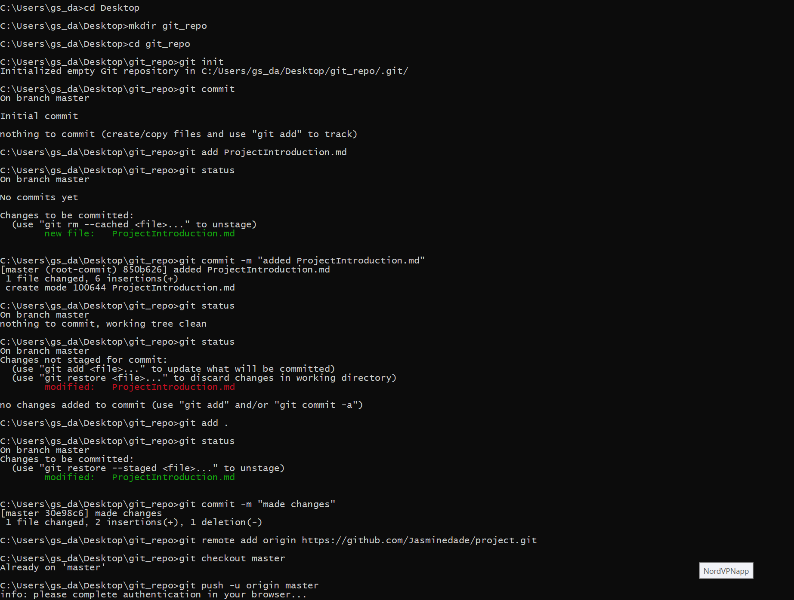

Results of section 3 –

* In step 5 , I logged in Github and created repository .
* In step 6 , I made some changes in it the ProjectIntroduction.txt and add the git file . After I checked the status and committed .
* In step 7 , I set up the remote repo and added remote URL and then by pushing git again added file and checked status . This is called Edit/Status/Commit/Push .

List of git commands –

|  |  |
| --- | --- |
| Commands | Functions |
| git add <file> | It adds a change in the working directory to the staging area. |
| git status | It displays the state of the working directory and the staging area. |
| git commit | It captures a snapshot of the project's currently staged changes. |
| git push | It is used to upload local repository content to a remote repository. |

Conclusion –

In this assignment I created project.git in the git and github as well as created set up repository. And created a file called ProjectIntroduction.txt by which I done Edit/Stage/Commit/Push cycle.

Basically, this assignment tells about the git and github functions and features.

References –

[INFO1113 - GIT Resources | Multy.me](https://multy.me/Yd7fSu)